Abelardo Garcia, Sai Lakshman Ethakatla, Ramyanth Nakshathram

04/19/2022

CIS 5364 Data Warehousing

Homework 4

SAP BW/4HANA login username: BN1-037

**Screen Shots 1** and **2 – Exercise 3.2 – Modeling Basics** **(4 points):**

Screenshot for *Figure 19* on *page 14* of **Exercise 3.2**.

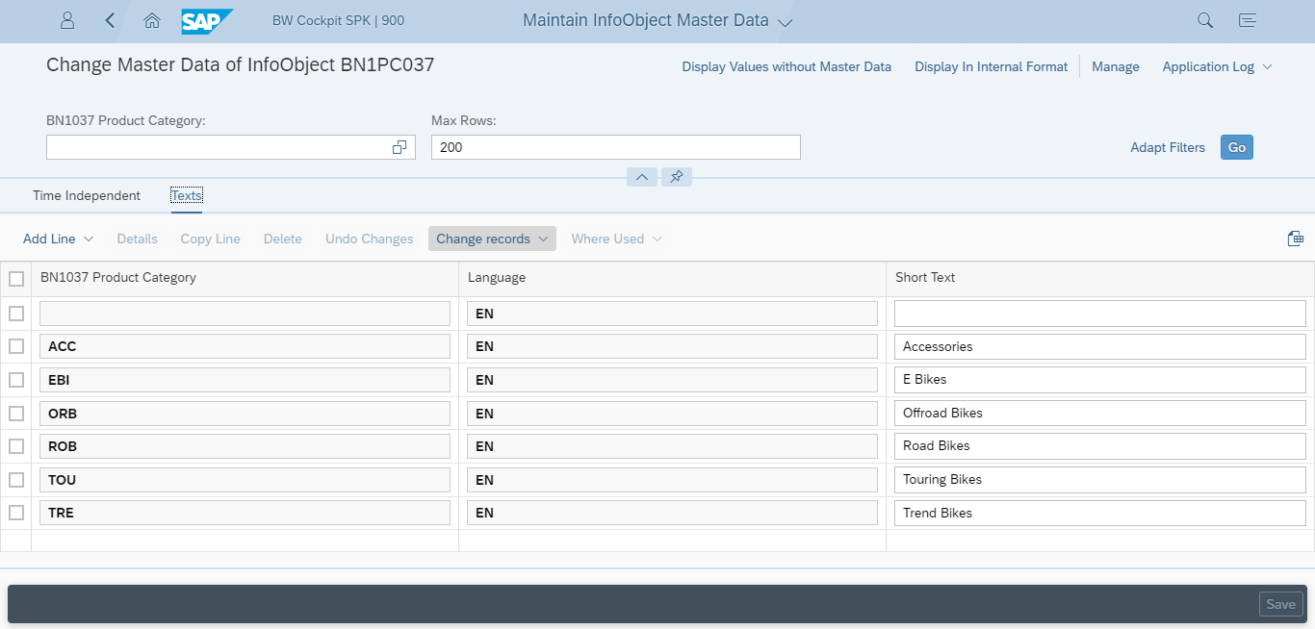

Screenshot for *Figure 25* on *page 19* of **Exercise 3.2**.

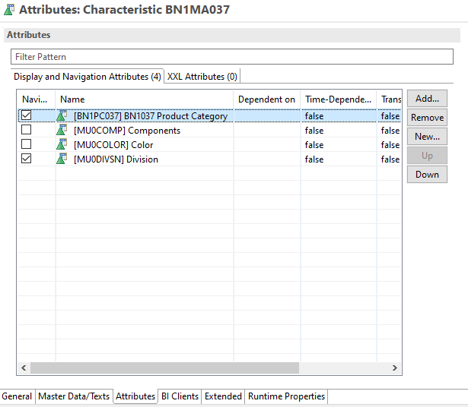

**Screen Shots 3, 4** and **5 – Exercise 4.1 – Master Data** **(7 points):**

Screenshot for *Figure 21* on *page 15* of **Exercise 4.1.**

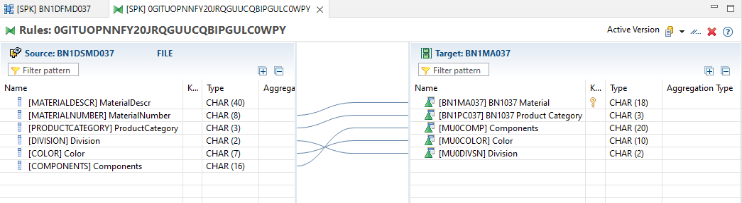

Screenshot for *Figure 34* on *page 23* of **Exercise 4.1**.

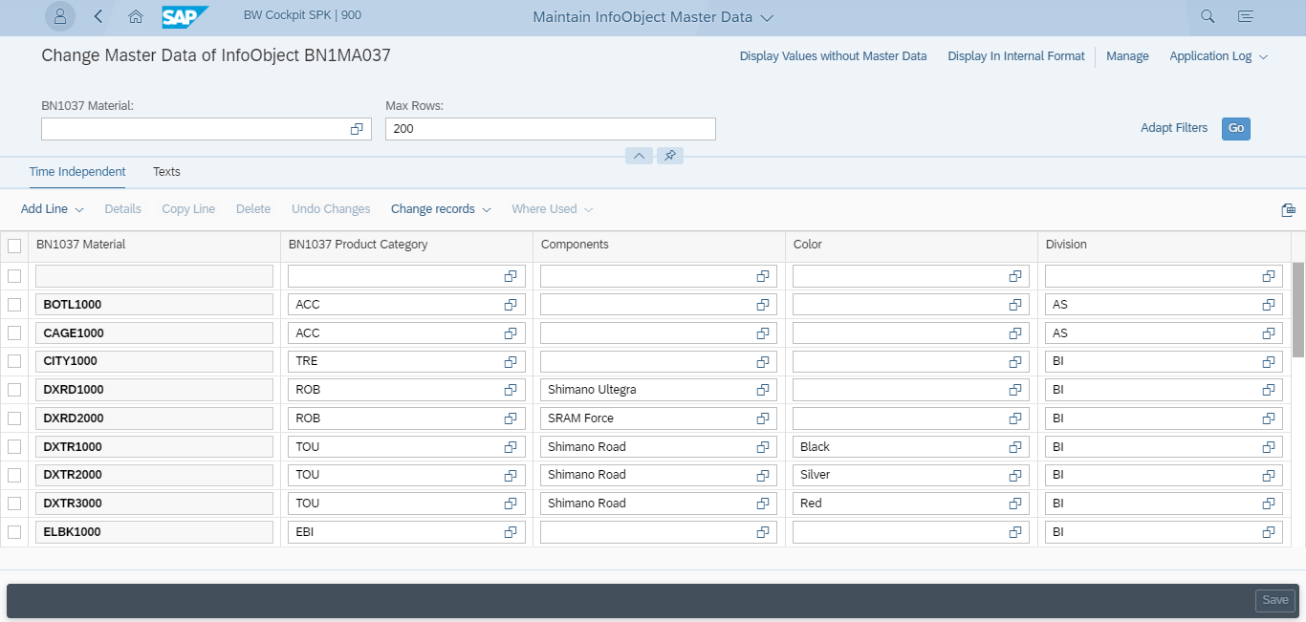

Screenshot for *Figure* on *page 30* of **Exercise 4.1**.

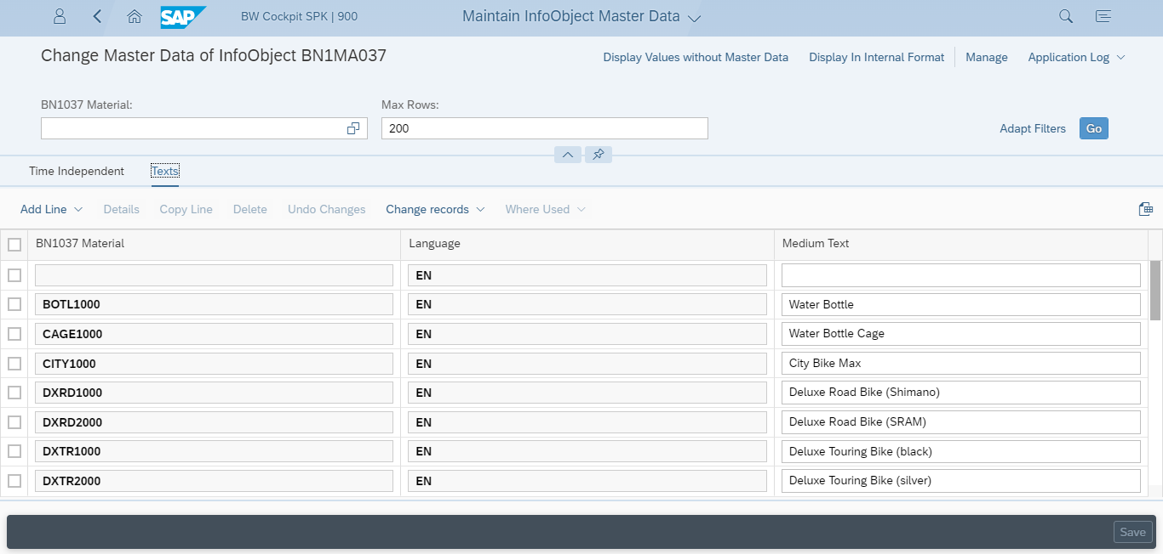

**Screen Shots 6** and **7 – Exercise 4.2 – Data Acquisition** **(7 points):**

Screenshot for *Figure 9* on *page 10* of **Exercise 4.2**.

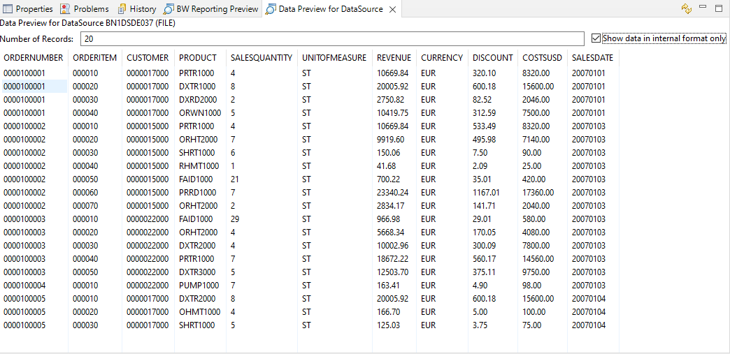

Screenshot for *Figure 14* on *page 13* of **Exercise 4.2**.

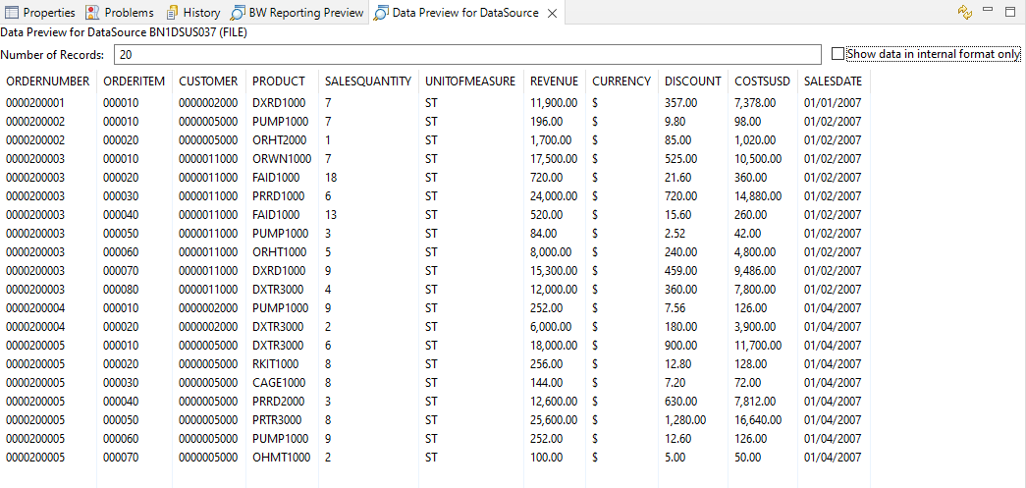

**Screen Shots 8, 9** and **10** **– Exercise 4.3 – Enterprise Data Warehouse** **(12 points):**

Screenshot similar to *Figure 18* on *page 16* of **Exercise 4.3** *for completed transformation*.

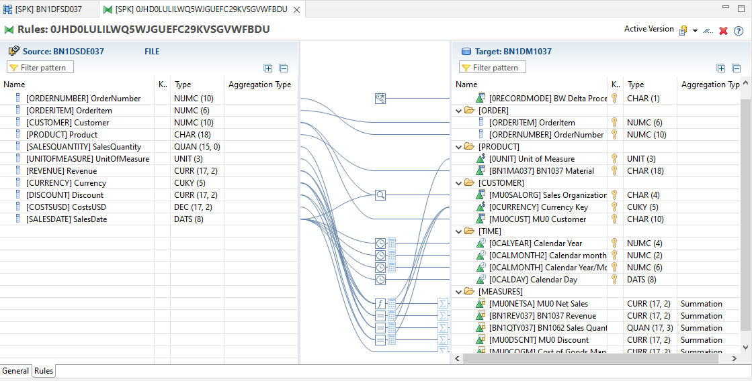

Screenshot *Figure 43* on *page 31* of **Exercise 4.3**.

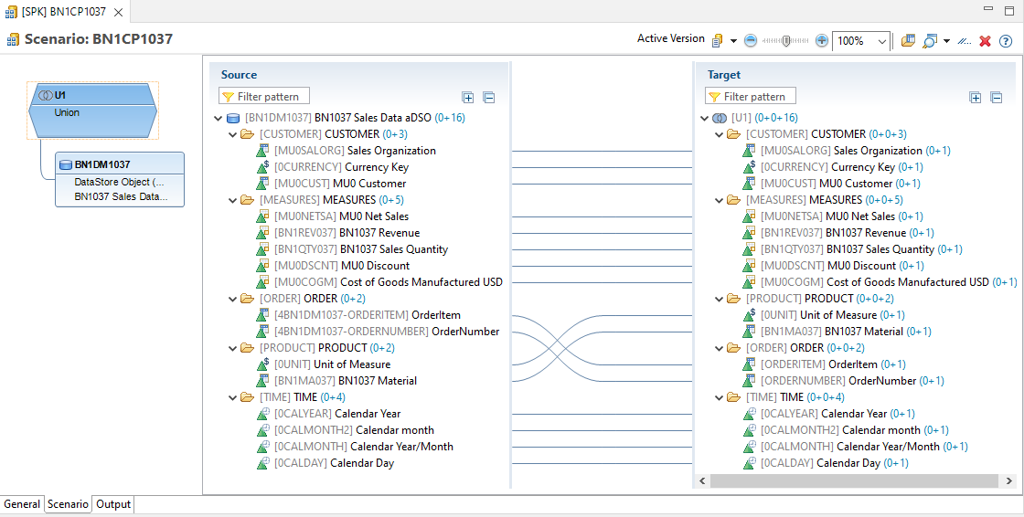

Screenshot *Figure 46* on *page 34* of **Exercise 4.3**.

